**Create Document library**

Go to Classic Team Site 🡪 Click Settings 🡪 Add and App

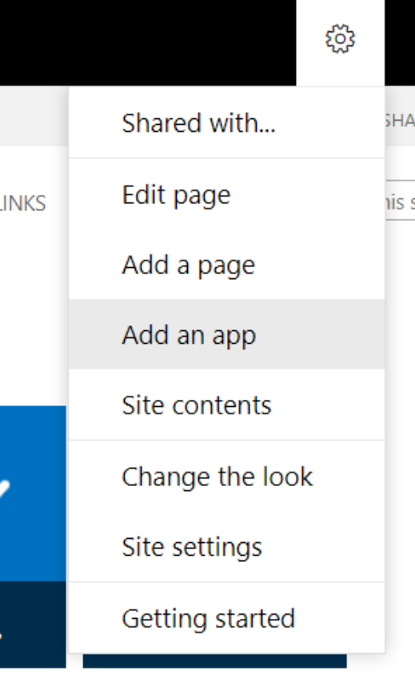

Select Document Library

Give Name “Demo Documents”

Click Create

Then Click Demo Documents from the list to open the created document library

**Upload files and folders to a library**

* Click Upload or drag and drop file

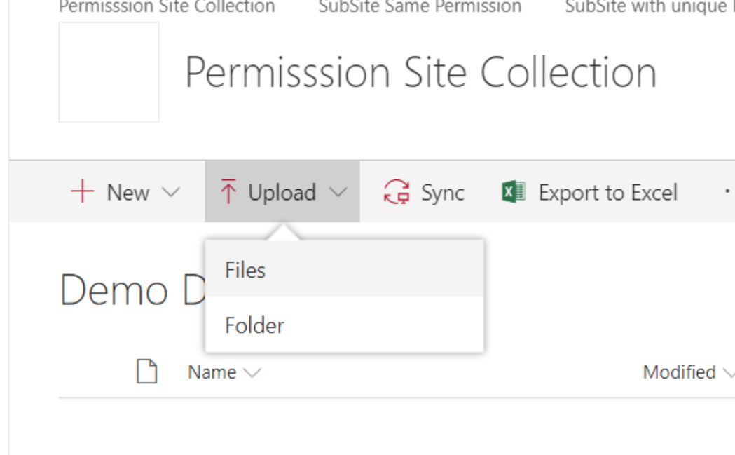

Or

**Move or copy a folder, file, or link in a document library**

Create one folder to move or copy files

Select folder and move it

It moves the file to new folder

It will remove from existing folder and move to new folder

**Copy Files to new folder**

Same as move files, but it will create a duplicate files in the new folder

**Enable and configure versioning for a list or library**

1. Go to the library or list for which you want to enable versioning.
2. Go to settings and select library settings

1. On the **Settings** page, select **Versioning Settings**.

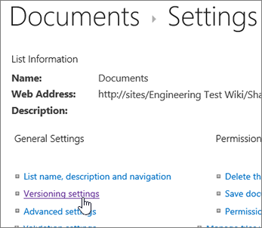

1. In the **Version Settings** page, the following settings are available:
   * **For a Document library**

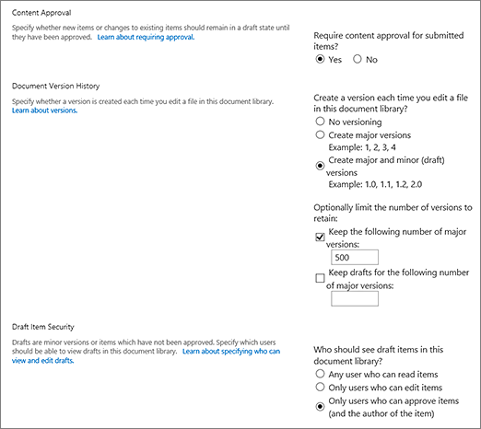

* + - Require content approval for submitted items.
    - Create a version each time you edit a file in this document library, either major versions only, or major and minor versions.
    - Limit the number of versions and drafts to retain.
    - Set who can see draft items.
    - Require documents to be checked before they can be edited.
  + **For a List**
    - Require content approval for submitted items.
    - Create a version each time you edit an item in the list.
    - Limit the number of versions and drafts to retain.
    - Set who can see draft items in the list.

1. Select **OK**.

**To disable versioning in a SharePoint 2019 library**

Do the same steps for enabling, but on the **Version Settings** page, select **No versioning**. For **Require content approval**, you can also select **No**.

To view, restore, or delete an earlier version

To restore an earlier version of a document, follow these steps.

1. Go to the list or library with the item or document for which you want to view history.
2. Go to the **File**, or select **Item** select the **...** (ellipses).

1. Select **Version History**.

If you don't see **Version History**, in the dialog, select the **...** (ellipses), and then select **Version History**.

1. In the **Version History** dialog, hover your mouse over the date link on an earlier version, and to show the menu, select the down arrow.

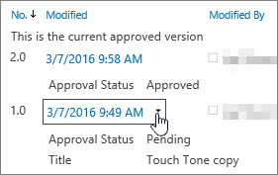

1. In the menu, you can do the following.

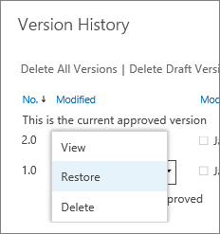

* + **View** the current document. A dialog appears where you can edit, restore, or delete, as well as see the current approval status.
  + **Restore** the document. A dialog appears prompting if you want to make it the currently approved document. It will add it as a new version.
  + **Delete** the document. A dialog appears prompting if you're sure you want to send the item to the Recycle Bin.
  + **Reject this version**. Only appears on approved documents, rather than **Delete**.

1. When you're done, click the **X** in the upper right corner.

**Require check out of files for editing**

Go to the library you plan to work in.

1. Select **Settings** Settings: update your profile, install software and connect it to the cloud  > **Library Settings**.

If you don't see these menu items, on the ribbon, select **Library**, and in the **Settings group**, select **Library settings**.

1. On the **Settings** page, under **General Settings**, select **Versioning settings**.
2. In the **Require Check Out** section, under **Require documents to be checked out before they can be edited?**, select **Yes**.
3. To save your settings and return to the **Library Settings** page, select **OK**.

**Break permission inheritance in SharePoint**

Now you've got to the **Permissions**page. Next, you will need to break permission inheritance before you can assign unique permissions, change permissions levels, or remove user permissions to a list, library, or survey. When you break permissions inheritance for a list, library, or survey and then define new permission settings, the list (or library) becomes a parent for items in it. Items under that parent now inherit the new permission settings (unless the items have uniquely defined permissions.)

To break inheritance and assign unique permissions, follow these steps:

1. Go to the list, library, or survey and open it.
2. Go to the **Permissions** page using the [steps in the previous section](https://support.microsoft.com/en-us/office/customize-permissions-for-a-sharepoint-list-or-library-02d770f3-59eb-4910-a608-5f84cc297782#bkmk_goto).
3. To break permissions inheritance from the parent, select **Stop Inheriting Permissions**.

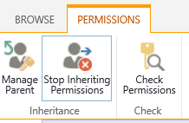

**Notes:**

* When a list or library contains more than 100,000 items, you can’t break permissions inheritance on the list itself. Nor can you re-inherit permissions on the list itself.
* When a folder contains more than 100,000 items, you can’t break permissions inheritance on that folder itself. Nor can you re-inherit permissions on that folder itself.
* Items within the library or folder hitting the limit (say a single file or folder) won't be impacted—so you could still, for example, break inheritance on any single file inside a library with greater than 100,000 items.
* When a user shares a document or other individual item, inheritance is automatically broken for that item. Inherited permissions are copied to the item, and permissions for the users with whom the item was shared are added. If changes in permissions are made to the parent item, those changes are not applied to the item.

**Assign unique permissions in SharePoint**

Once you've broken inheritance using the steps in the section above, follow these steps to grant unique permissions:

1. Go to the list, library, or survey and open it.
2. Go to the **Permissions** page using the [steps in the previous section](https://support.microsoft.com/en-us/office/customize-permissions-for-a-sharepoint-list-or-library-02d770f3-59eb-4910-a608-5f84cc297782#bkmk_goto).
3. **Select Grant Permissions** on the **Permissions** tab.

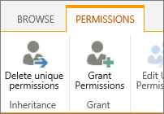

**Note:**If the list or library is inheriting from the parent, you won't see **Grant Permissions**.

1. In the **Share...** dialog box, make sure **Invite people** is selected, and then type the names of the people or group you want to grant access to in the **Enter names or email addresses...** box.

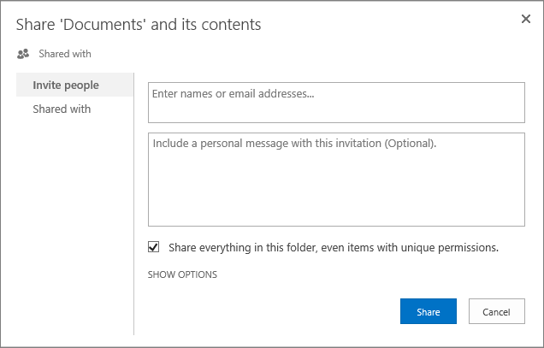

1. Add a personal message if you like.
2. Check or uncheck **Share everything in this folder, even items with unique permissions**. This will grant or restrict access to items you already set unique permissions for. (This option is only available for folders.)
3. The permission level granted is set to **Edit** by default, which means the people you invite can make some changes to the list, library, or survey. If you want to grant a different permission level like **Read** only, click **Show options** and change the selection in the **Select a permission level** box.
4. An email message will be sent to everyone in the **Invite people** box. If you don't want this to happen, click **Show options,**and uncheck **Send an email invitation**.
5. When you're done, click **Share**.

**Create Views**

* Go to Library Settings
* Click Create View under Views section
* A screenshot of a computer

  Description automatically generated
* Then create views
* Add filter
* Add sorting
* Add grouping
* Totals
* Ref Lab 16a for step by step views creation.

**Create or add a column in a list or library**

Columns in a list or library help you group, categorize, and track information. Column types include a single line of text, a drop-down list of options, a number that is calculated from other columns, and a column that allows you to select a person's name.

Add a column to a list or library

You can add most types of columns without leaving your list or library.

1. Navigate to the list or library you want to create a column in.
2. To the right of the last column name at the top of the list or library, select **+ Add column** or **+**.

**Note:**Does your SharePoint screen look different than the examples here? If so, select the **Classic** tab earlier in this article. You'll find alternate instructions there that'll match your experience better if your administrator set the classic experience on the list or document library, or if you're using an earlier version of SharePoint Server. See [Which version of SharePoint am I using?](https://support.microsoft.com/en-us/office/which-version-of-sharepoint-am-i-using-3575ff57-037f-48cf-9398-99080c34b25f)

1. In the dropdown, select the type of column you want.
2. In the **Create a column** panel, in the **Name** field, enter a title or column heading.

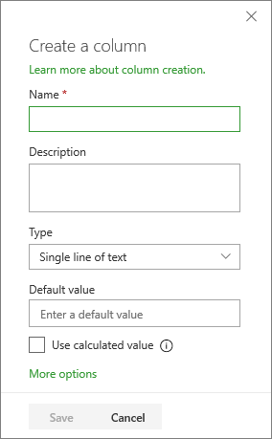

1. Enter any other required information. The number of fields will vary with column type you choose. The above example is for a 'number' field.
2. Select **Save**.

**Add more columns types to a list or library**

1. Navigate to the list or library where you want to create a column.
2. In the **All items** or **All documents** view of the list or library you want to add a column, select **Add column**   Add column icon at the end of the heading row, and then select **See all column types**. Select **Next**.
3. In the **Name and Type** section, enter the name that you want for the column in the **Column name** field.
4. Under **The type of information in this column is**, select the type of information that you want to appear in the column. For more info about column types, see [Site column types and options](https://support.microsoft.com/en-us/office/list-and-library-column-types-and-options-0d8ddb7b-7dc7-414d-a283-ee9dca891df7).
5. In the **Additional Column Settings** section, enter a description in the **Description** field to help people understand the purpose of the column and what data it should contain. This description is optional.

Depending on the type of column that you selected, more options may appear in the **Additional Column Settings** section. Select the additional settings that you want. For more info about column settings, see [Site column types and options](https://support.microsoft.com/en-us/office/list-and-library-column-types-and-options-0d8ddb7b-7dc7-414d-a283-ee9dca891df7).

1. You can add validation to make sure the column entry matches what's expected. To expand the section, select **Column Validation**, and enter the **Formula** that you want to use to validate the data. Add a **User message** that describes what valid data should look like to help users enter valid data. For info about validation and formula syntax, see [Examples of common formulas in lists](https://support.microsoft.com/en-us/office/examples-of-common-formulas-in-lists-d81f5f21-2b4e-45ce-b170-bf7ebf6988b3).

The **Column Validation** section is not available for all types of columns.

1. To save, select **OK**.